**3. Requirements Analysis**

**3.1. Problem Statement**

Over the last 2 decades, wildfires have grown in both size and frequency. They damage property, materials used to produce many goods used across the world, they contribute to large scale air pollution, and cause a number of people their lives every year.

Key applications like Emxsys are crucial in mitigating wildfire risks. By integrating modern marketing and distribution methods alongside an updated support service, Emxsys can be utilized by more people to improve the outcome of wildfires.

**3.2. Problem Analysis**

While there are many different stakeholders to consider, we will focus on the users, customer support, and marketing employees.

The users are a wide range of individuals, but will likely use the product in similar ways. Features will be added to the platform to take in user data to identify the demographic that will most likely use the product, or want to know information that the product produces. This could range from the average resident in a wildfire prone location, local government officials, and the wildfire fighters themselves.

The second stakeholder we will focus on is a customer support specialist. Their primary role will be to make the product as usable as possible for any type of user. The underlying mechanics may be complex, but getting the user to understand the produced information could be simple. Also, providing customer support will increase the effectiveness of the system by allowing more people to fully use all features. To increase usability, we will also be adding a tutorial feature so that users make the most of their experience with Emxsys.

The final stakeholder that we will focus on is the marketing employee. By collecting demographic data, marketers can more effectively identify groups of people that would benefit from the user of Emxsys. They could then target the product to certain groups of people that would obtain the application. The more people that have the product and are able to predict wildfire behavior, the more the problem of wildfires is mitigated.

**3.3. Business Case**

**3.3.1 Costs**

There are three main costs that we expect to be associated with the system upgrades. The cost to build the new updates, the costs to run the new marketing team, and the cost of customer support personnel.

* The initial data collection update to the system will require a team of 8 at $45/hour for one month will cost approximately $60,000.
* The Tutorial creation will require a team of 6 at $45/hour for one month will cost approximately $45,000
* The marketing team will consist of 4 personnel at approximately $40,000/ year will cost $160,000 per year
* The customer support team will be 3 personnel at approximately $40,000/ year will cost $120,000 per year

Overall, the system will cost somewhere around $105,000 for the initial updates, and the new staff will cost $280,000 per year to provide support.

**3.3.2 Benefits**

Wildfires in 2018 totaled a cost of $81 billion dollars in property and asset damages across the United States. The benefit to improvements on marketing and usability, even if it is very small, would save far more in damages, than cost per year. Additionally, getting the information from this system into the hands of as many people as possible has the potential to save lives.

* Getting wildfire behavior prediction information to forestry industry management could allow them to mobilize assets earlier to avoid damages by wildfires.
* Giving people the tools to predict wildfire behavior can allow them to properly plan where to build housing development to reduce the likelihood of getting caught in a wildfire.
* Predicting wildfire behavior can enhance local government policies and contingency plans to reduce the effects of wildfires on local communities.

If the information is available to as many people as possible, we predict we could reduce wildfire impacts by approximately 0.01% which would save the United States $8.1 million annually.

**3.4. Solution Analysis**

**3.4.1 Class Diagram for GeoSpatial Analysis**

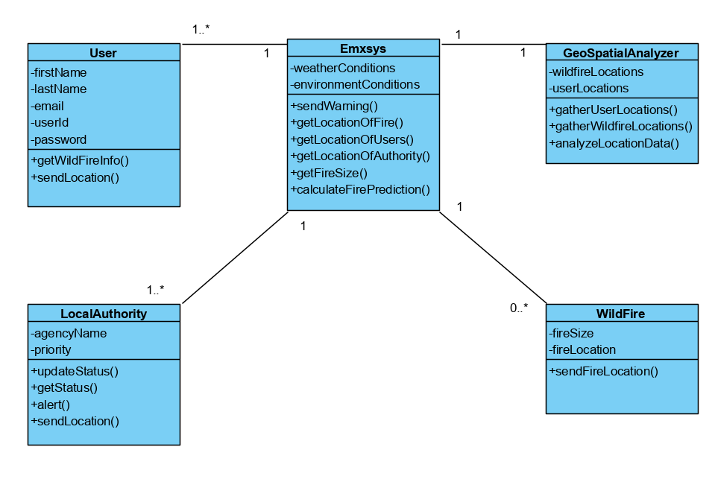

**User:** Represents users registered with the Emxsys. The user has a function to send its location to the Emxsys so that the system can correctly notify users in wildfire hazard areas of their danger.

**LocalAuthority:** Represents local officials that have a duty to alert local workers and residents of wildfires. Can alert the Emxsys to alert users of additional hazards the Emxsys has not handled.

**Emxsys:** The system that collects and directs appropriate information about users and wildfires to affected locations.

**GeoSpatialAnalyzer:** Interprets data about wildfire and user locations to help assess the overall wildfire threat to users.

**WildFire:** Represents the wildfire hazard. Has information about the wildfire to aid the Emxsys in making its prediction.

**3.4.2 Static Structure:** The static structure of the solution consists of an extension to the current application. This will give the application the ability to actively track the users and the local authorities so that they can more effectively be notified if they are in any sort of danger of a wildfire, or if they will be in danger in the near future.

**3.4.3 Dynamic Behavior:** The dynamic behavior includes the interaction of the Emxsys with the users and the Geolocation Analytics tool. The system must track the locations of the users and the locations of the wildfires. It can then assess the danger that the users may be in, and then can notify them in real-time of the wildfire’s predicted path and a possible emergency plan.

**3.4.4 Sequence Diagram of How Geolocation Analytics works**

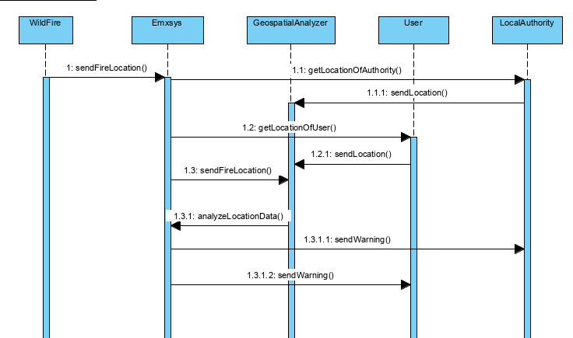

**3.5. Storyboard**

* Title: Emxsys notifies a community of a fire
* Description: In this storyboard, we will observe how Emxsys is used to notify and provide data to a community about a local fire.
* Cast of Characters:
  + Jim: A local farmer and Emxsys user.
  + Lisa: A dispatcher that is notified by Emxsys and sends information to authorities.
  + Sarah: An elderly homeowner. She does not use Emxsys.
  + Mike: A local farmer. He does not use Emxsys.

Emxsys uses the WildFire feature to observe a rural community for any developments in a wildfire prone area. One day, the WildFire feature notices an impending fire hazard near the community.

Emxsys uses the WildFire prediction to notify Lisa, a dispatcher for the local authorities. Lisa is then able to take the data given to her by Emxsys and forward it to the local firefighters to help them predict where a fire could start and minimize the damage of any possible wildfires, saving lives and preventing property damage.

At the same time Jim, a local farmer and a user of Emxsys, is also notified of an impending risk of a wildfire. He is able to use the Geo Spatial Analyzer to help explain the risk and impact of the impending situation easily to himself, his family, and his neighbors and is armed with information necessary to prepare his family and his property. He uses the time gained from the wildfire prediction to move his expensive farm equipment to a safer location and evacuates his family to safety, grateful for the warning from Emxsys.

On the other hand Sarah, a homeowner close to the wildfire danger zone, does not use Emxsys. She is unaware of the situation and continues on with her day. Quickly, a wildfire develops and she gets notified by her local authorities using the information provided by Emxsys. She uses the warning as a chance to evacuate herself and her valuables. Thankful for the warning from the authorities but worried that she was not prepared for the situation herself.

Lastly Mike, another farmer close to the wildfire danger zone, does not use Emxsys. He is unaware of the situation and continues on with his work, business as usual. He is also unable to be reached by his authorities. The smoke gets too close to his property until Mike begins to notice. He panics and uses what little time he has to gather his family and his most essential valuables before he evacuates. In doing so, he suffers property damage that could have been avoided if he was aware.

After the fire is dealt with and the community attempts to return to normalcy, the impact of Emxsys becomes apparent. Jim is very happy with the money he was able to save from being prepared and aware of the situation and recommends it to all of his friends and neighbors. Sarah is also relieved from her successful evacuation and learns of the help of Emxsys through the community. She is older and not very technically proficient but she uses a friend to help her access Emxsys. She uses it to the best of her ability and with the help of the customer support but even if she is not comfortable using it, the local authorities are still using it and have her protected. Finally, Mike is disappointed with the losses he suffered in the fire and wishes he was better prepared. He finds out that other community members like Jim were using Emxsys to notify them and quickly becomes a user to protect himself and prevent another loss.

Through this situation, Emxsys is able to aid its users and the local authorities to protect themselves and minimize damage. The situation also spreads awareness of the usefulness of the app to the community members, helping Emxsys gain many new users.

**3.6. Functional Requirements**

* Most essential requirements

** Most essential requirements

1. (*) System must provide users with up to date wildfire information
2. (**) System must deliver complicated information in a user friendly format
3. (*) System must track data from all over the world and calculate the data for wildfire possibilities
4. (*) System must track user information to better serve customers
5. System should successfully notify users accurately and in a timely manner in case of emergency
6. System should provide an easy avenue to support and help for difficulties

**3.7. Actors**

|  |  |
| --- | --- |
| Actor | Description |
| User | A civilian who uses Emxsys to help them prepare and understand local wildfires. |
| Local Authority | A local authority (firefighter, dispatcher, etc.) in charge of the protection of their jurisdiction. They use Emxsys most intensively to help them predict any upcoming wildfires and help protect citizens. |
| Customer Support | An employee of Emxsys who provides support to users of Emxsys. They help users learn to use Emxsys and provide any help with problems. |
| Market Researcher | An employee of Emxsys whose job it is to research new strategies to increase Emxsys adoption. They look at trends in data and see if there's any pathways to improve adoption or general user experience. |

**3.8. Use Cases, Scenarios, User Stories**

**3.8.1 Emxsys Notifies a User and Local Authority**

**3.8.1.1 Functional Objectives:** 1, 2, 3, 5

**3.8.1.2 Description:** In this a user and local authority enter their location and receive information about possible wildfires.

**3.8.1.3 Scenario: The Alert Process**

|  |  |
| --- | --- |
| **Actors** | User, Local Authority |
| **Assumptions** | * The user and local authority have devices to access the service |
| **Happy Path** | 1. User/ local authority enters their location to check wildfire data 2. Data is shown 3. Data can be used to predict upcoming wildfires 4. Users/ local authority use data to help prepare themselves/ community for wildfire |
| **Error Path** | 1. The user/ local authority does not have their location entered 2. The user/ local authority does not check their device for information 3. The local authority fails to report status to citizens |
| **Outcomes** | * The system notifies user/ local authority of impending wildfires * The local authority successfully notifies citizens of impending wildfires |

**3.8.1.3.1 Associated User Stories**

|  |  |  |  |
| --- | --- | --- | --- |
| ID | As a/an | I want to.. | So that.. |
| 1 | User | Enter my location and receive wildfire data in an easy to understand manner | I can prepare myself for any incoming wildfires |
| 2 | Local Authority | Enter my location and receive detailed information to monitor and predict wildfire patterns | I can protect and warn the citizens of my local jurisdiction |

**3.8.2 Market Researcher Looks at Trends in Data**

**3.8.2.1 Functional Objectives:** 4

**3.8.2.2 Description:** A market researcher looks at user data to determine where the user base can be expanded and where marketing can be improved.

**3.8.2.3 Scenario: Market Researcher Looks at Trends in Data**

|  |  |
| --- | --- |
| **Actors** | Market Researcher |
| **Assumptions** | * There is a large enough user base to base data off of |
| **Happy Path** | 1. Market Researcher accesses user data\ 2. Shown trends and charts of data 3. Researcher can analyze where user base is most dense and the usage of each user |
| **Error Path** | 1. There is no user base to analyze |
| **Outcomes** | * The company can develop new marketing strategies with the knowledge received from market research |

**3.8.2.3.1 Associated User Stories**

|  |  |  |  |
| --- | --- | --- | --- |
| ID | As a/an | I want to.. | So that.. |
| 3 | Market Researcher | Keep track of where the user base is mostly located | I can judge where the user bas needs to improve as well as analyze what kind of communities are most likely to use this service |
| 4 | Market Researcher | Ask users how they found the service | I can find the most popular method of recommendation for the service as well as develop different methods of marketing |

**3.8.3 Customer Support Provides Support to Users**

**3.8.3.1 Functional Objectives:** 6

**3.8.3.2 Description:** Customer support can be used to educate users on

how to correctly and efficiently use the service as well as provide help

**3.8.3.3 Scenario: Customer Support Provides Support to Users**

|  |  |
| --- | --- |
| **Actors** | Customer Support, User |
| **Assumptions** | * Customer support is knowledgeable enough about the service to provide accurate help |
| **Happy Path** | 1. User needs help with the service 2. User visits the customer support portal    1. User can watch tutorials to help themselves figure out their issue 3. User contacts a support representative 4. Customer support provides help until customer is satisfied |
| **Error Path** | 1. The user cannot find the support portal 2. The support is not helpful to the customer |
| **Outcomes** | * User experience is improved by providing support to help users understand complicated wildfire data |

**3.8.3.3.1 Associated User Stories**

|  |  |  |  |
| --- | --- | --- | --- |
| ID | As a/an | I want to.. | So that.. |
| 5 | User | Have a knowledgeable and thorough support portal | I can get help when I am confused or have a problem with the service |
| 6 | Customer Support Representative | Provide knowledgeable support to customers | I can successfully help customers with any issue while improving customer satisfaction |

**3.11. Use Case Diagram**

Explains at a high level who is interacting with what system.

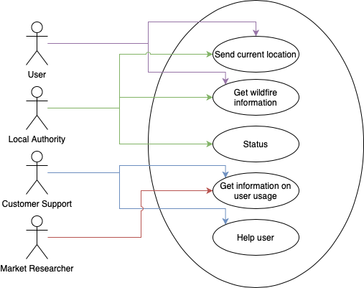

**3.12. Non-Functional Requirements:**

Priority is marked by the number in parenthesis. 1 is the highest priority and 3 is the lowest priority.

**3.12.1 Availability:**

1. (1) The system must be available 24/7 since it is an emergency platform.
2. (1) Customer support must be available 24/7 since it is an emergency system and users might need support for an emergency at any time.
3. (1) All issues must be identified immediately.

**3.12.2** **Modifiability/Scalability:**

1. (3) System should be able to handle thousands of users interacting with the system at once from different locations, but the likelihood of multiple catastrophic wildfires happening concurrently are low but not impossibly.
2. (3) System should support the ability to add tutorials.

**3.12.3 Performance:**

1. (2) System should be able to handle collecting data on thousands of concurrent users without slowing down the system.
2. (1) System should be able to handle multiple wildfires at once.

**3.12.4 Security:**

1. (1) Keep user information private.
2. (1) System should be secure enough to prevent malicious users from altering wildfire information.
3. (1) System should not allow malicious users access to location services.

**3.12.5 Testability:**

1. (2) System should log all unique requests made within 30 seconds.

**3.12.6 Usability:**

1. (1) Easy to use interface since users most likely will not be tech savvy.

**3.13. Acceptance Plan:**

* All functional requirements in the released system must pass acceptance testing
* Availability:
  + System must be available 24/7.
  + Customer support must be available 24/7 to support users with any issues.
  + Test with:
    - 1000 concurrent users
    - Multiple regions
  + All issues must be identified immediately
  + Test with:
    - All regular and boundary issues.
* Modifiability/Scalability:
  + System should be able to handle thousands of users interacting with the system at once from different locations.
  + Test with:
    - Thousands of users all in different locations
    - All making concurrent requests
  + System should support the addition of tutorials
  + Test with:
    - A new tutorial being added every week
* Performance:
  + System should be able to handle collecting data on thousands of concurrent users without slowing down the system.
  + Test with:
    - 10,000 different users from different locations all interacting with systems. Specifically location services.
  + System should be able to handle multiple wildfires at once.
  + Test with:
    - Multiple simulated wildfires.
* Security:
  + Keep user information private.
  + System should be secure enough to prevent malicious users from altering wildfire information.
  + System should not allow malicious users access to location services.
  + Test with:
    - 100 ethical hackers.
* Testability
  + System should log all unique requests made within 30 seconds.
  + Test with:
    - 1000 cases
* Usability
  + Easy to use interface since users most likely will not be tech savvy.
  + Test with:
    - 20 users, all of varying technical ability